# PROFESSIONAL TRAINING REPORT

# At

**SATHYABAMA INSTITUTE OF SCIENCE AND TECHNOLOGY**

Submitted in partial fulfillment of the requirements for the award of

Bachelor of Engineering Degree in

Computer Science and Engineering

By

**SONISH.S (REG.NO 37110729)**

# DEPARTMENT OF COMPUTER SCIENCE AND ENGINEERING SCHOOL OF COMPUTING

**SATHYABAMA**

**INSTITUTE OF SCIENCE AND TECHNOLOGY**

**(DEEMED TO BE UNIVERSITY)**

**Accredited with Grade”A” by NAAC**

**JEPPIAAR NAGAR, RAJIV GANDHI SALAI, CHENNAI – 600119.**

**AUGUST 2019**

**SATHYABAMA**

**INSTITUTE OF SCIENCE AND TECHNOLOGY**

**(DEEMED TO BE UNIVERSITY)**

**Accredited with Grade “A” by NAAC**

# JEPPIAAR NAGAR, RAJIVGANDHI SALAI, CHENNAI - 600 119

# www.sathyabama.ac.in

**DEPARTMENT OF COMPUTER SCIENCE AND ENGINEERING**

**BONAFIDE CERTIFICATE**

This is to certify that this Project Report is the bonafide work of **SONISH.S** **(Reg. No 37110729)** who carried out the project entitled “**OBJECT DETECTION USING ULTRASONIC**” under our supervision from MAY 2019 to JUNE 2019.

**Internal Guide**

**Mrs. M. D. ANTO PRAVEENA, M.C.A., M.E, Ph.D.,**

**Head of the Department**

## Dr. S. VIGNESHWARI, M.E., Ph.D.,

**Submitted for Viva voce Examination held on_____________________**

**Internal Examiner External Examiner**

**DECLARATION**

I **SONISH .S**(**Reg. No. 37110729)** hereby declare that the Project Report entitled “**OBJECT DETECTION USING ULTRASONIC”**done by me under the guidance of **Mrs. M. D. ANTO PRAVEENA, M.C.A., M.E., Ph.D.,** is submitted in partial fulfillment of the requirements for the award of Bachelor of Engineering degree in Computer Science and Engineering.

## DATE:

**PLACE:**  **SIGNATURE OF THE CANDIDATE**

**ACKNOWLEDGEMENT**

I am pleased to acknowledge my sincere thanks to Board of Management of SATHYABAMA for their kind encouragement in doing this project and for completing it successfully. I am grateful to them.

We convey our thanks to **Dr. T. SASIKALA, M.E., Ph.D., Dean, School of Computing** for providing us the necessary support and details at the right time during the progressive reviews.

I convey my thanks to **Dr. S. VIGNESHWARI** Head of the Department of Computing for providing me necessary support and details at the right time during the progressive views.

I would like to express my sincere and deep sense of gratitude to my Project Guide **Mrs. M. D. ANTO PRAVEENA, M.C.A., M.E., Ph.D.,** for his valuable guidance, suggestions and constant encouragement paved way for the successful completion of my project work.

I wish to express my thanks to all Teaching and Non-Teaching staff members of the Department of **COMPUTER SCIENCE AND ENGINEERING** who were helpful in many ways for the completion of my project.

**CERTIFICATE**

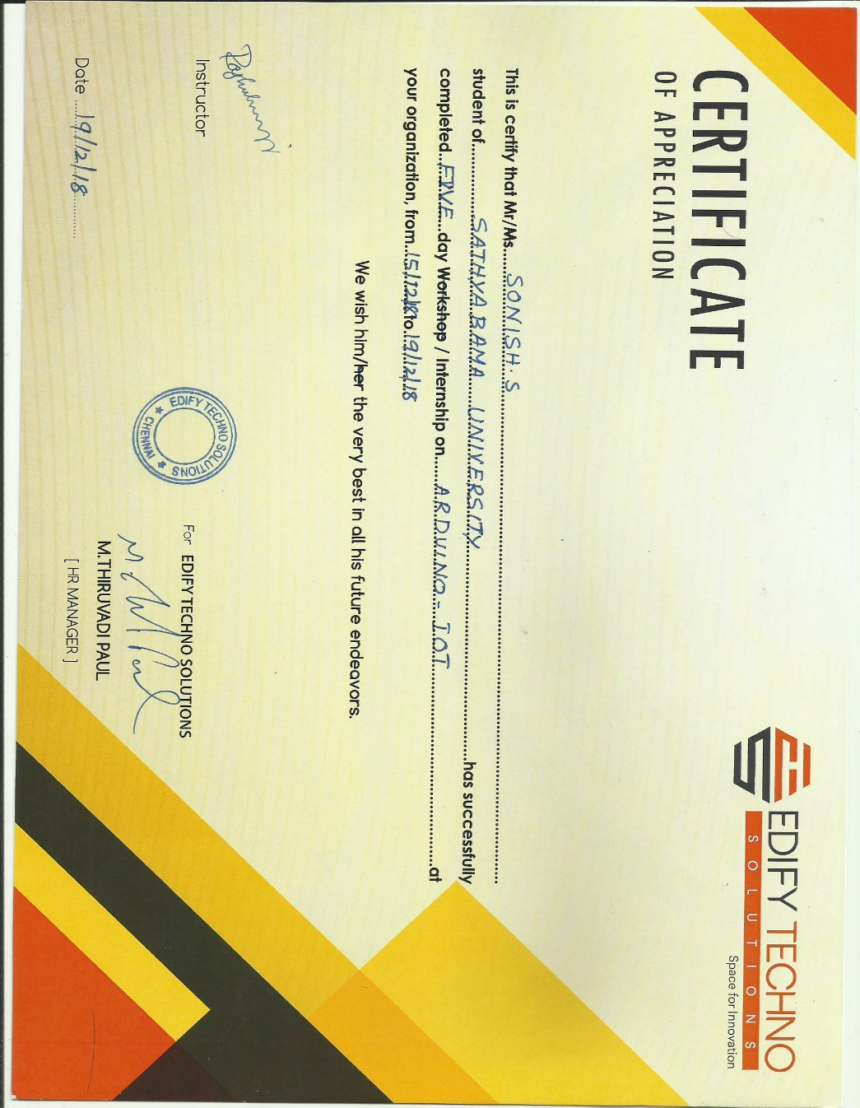

**ABSTRACT**

Object detecting information in traffic signals, vehicles contains plenty of important information on road safety. In this paper, we propose an algorithm that extract’s and tracks feature points of ultrasonic waves. The information is indispensable for measuring moving object, counting the number of vehicles, monitoring distance between two objects, classifying running directions, and monitoring congestion situation. Utilizing Ultrasonic operator for detecting objects and distance, feature points are extracted, followed by proximity sensors to track the feature points in moving vehicles. Many objects can be tracked at the same time automatically since the information is obtained from ultrasonic sensors. As an example, this paper shows how the distance between two objects can be measured Approximate height of object is 50cm. The result shows this algorithm needed to be add some method that can change the parameters to detect more than one object. Overall the implementation method in Arduino can successfully detect the moving object with accuracy above 90 percent.